Politics, Book V

Preliminaries
- when discussing Book III's discussion of ruling and being ruled, we asked whether Aristotle thinks there is an optimal size for the city:

  - At 1280b33, we saw that he thinks a city-state exists “only when households and families live well as a community whose end is a complete and self-sufficient life”? (1280b33)

    - what does "self-sufficienc[y]" mean? why is it desirable?

    - how big must a city be to realize that end?

  - Look at Josh Ober’s table for population and wealth in late 4th century Athens:

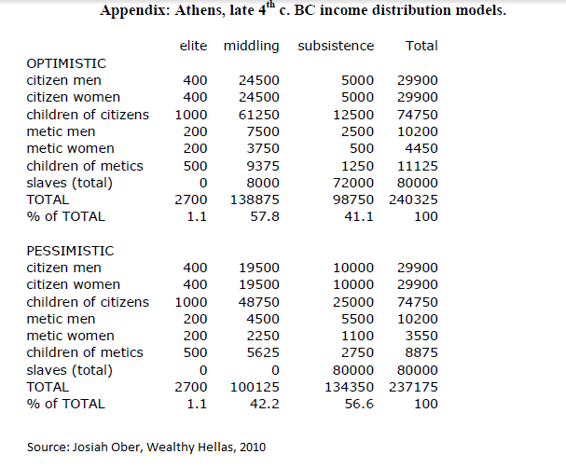

At 1326b15, Aristotle says that “each citizen must know what sorts of people the other citizens are”. How much specific mutual knowledge is required to satisfy this condition? If a great deal, does this condition impose upper limits on the size of the city? Is Athens itself too large?

- Aristotle sometimes seems to suggest that barbarians are natural slaves. Perhaps he thinks that barbarians lack deliberative capacities -- and so are naturally slavish -- because they lack the settled existence and high culture of Athens. We want to query whether Aristotle is right about why they lived as they did or whether there is some other explanation. Since barbarians lived outside the Greek peninsula, it is useful to look at recent work on the so-called “lucky latitudes”.

- a look at what we're missing - two moving passages from Book VII:

  - 1325a1 – Aristotle's students might think that the best constitution is one ordered toward conquest and that such a constitution would form citizens toward that end. Aristotle therefore offers an argument that the end of the best constitution cannot be conquest: a city in isolation can still be good.

  - 1325b18 - a city in isolation can be active, and so live the best life
↓
QUESTION: What activity is the good of the city – a self-sufficient life in which citizens give each other justice?

Cf. Rawls’s view that peoples need only the resources necessary to sustain democratic institutions. An ever-rising standard of living is not necessary as a matter of justice.

Note what a challenge to ways the ends of politics historically thought of:

- Glory = how one’s state is thought of by others – cf. Augustine on Rome
- Immortality = how one’s state will be regarded by history
- Conquest – driven by desire to dominate
- Pride – how citizens can see themselves
- Having the best or the biggest, e.g. cathedral – rivalry of Italian city-states
- Various ways of proving that one’s governing ideology is best – communist v. capitalist rivalry
- Fulfilling manifest destiny of some kind
- Ever-rising standard of living

Would this be stultifying? What improvement is possible? What are citizens to hope or to work for?

Now Let's Turn to Book V - We want to ask: how much is applicable to the modern world?
- walk through the six constitution types

  - who are the citizens in each?

  - what the differences are between the good and deviant constitutions?

- Much of Book V is devoted the destabilization and overthrow of regimes or constitutions.

  - Book V obviously contains a lot of anecdotal material which can seem rather quaint. For according to many of the anecdotes, regimes fell because of personal affronts and insults. Could that happen in the modern world where rulers are constrained by institutions and bureaucracies? If your answer 'yes', can you think of examples? If that sort of thing can happen in the modern world, how do we guard against it?

  - Aristotle thinks that change often comes about because of what he calls "faction"

    - what is a faction?

    - are political parties factions? was the Tea Party Caucus in the House of Representatives a faction?

    - if faction is a real danger, how can a free society avoid it without limiting associational liberty?
  - 1304a38 "Constitutions also undergo change when parts of a city-state that are held to be opposed, such as the rich and the people, become equal to one another and there is little or no middle class." Of course, the middle class could disappear without the rich and the poor becoming equal in number. Why is a middle class stabilizing?

  - For obvious reasons are especially interested in the vulnerability of polities and democracies.

    - At 1307a7, Aristotle speaks of the fall of polities. He writes:

Polities and aristocracies are principally overthrown, however, because of a deviation from justice within the constitution itself. For what begins the process in a polity is failing to get a good mixture of democracy and oligarchy, and in an aristocracy, failing to get a good mix of these and virtue as well.

      - what is a "mixed constitution"? why does Aristotle think they are especially stable?

      - Is US constitution as originally written a mixed constitution? Why or why not? If yes, should we revert to a mixed constitution or become more democratic?

    - He also reviews a number of vulnerabilities of democracies:

      - At 1304b20 Aristotle says that "Democracies undergo change principally because of the wanton behavior of popular leaders." What do you think he has in mind?

      - 1309a14 "In democracies, the rich should be treated with restraint, not only by not having redistributions of their property but by not having redistributions of their incomes either[.]" At 1309b40, he adds "by destroying these classes through extreme legislation they destroy the constitution." How could, say, a confiscatory income tax damage a democracy?

  - We might think that what Aristotle has to say is irrelevant to our situation, since it seems unlikely that our constitution will be overthrown anytime soon. But could we "translate" Aristotle's analyses to situations in which the constitution remains the same, but the distribution of power shifts so that a society is, say, nominally a polity but really an oligarchy?

- Aristotle is also understandably concerned with the ways in which regime-types are preserved.

  - At 1308a24, Aristotle says that constitutions can be preserved because dangers are close at hand. Why would he think that the presence of danger would help? Can you think of historical examples that illustrate his point?

  - At 1310a12, Aristotle stresses the importance of citizens' being educated in the way that suits their constitution. What might this mean for the US early in the 21st century? Are we doing a good job of educating for our constitution? Why or why not?

  - Aristotle studies the ways of preserving tyranny. One, discussed at 1313a34ff., we might call "the tyrannical ways to preserve tyranny." The second is discussed at 1314a30ff. How would you describe that argument?

These figures no doubt include those who lived outside the city of Athens; I don’t know how much of the Athenian population was urban. Note further that while Ober is a very reputable scholar, estimates of the population of ancient Athens vary widely. Ian Morris, The Measure of Civilizations says that Babylon was the most populous city of Aristotle’s time and he gives a figure of 150,000 – far less than Ober’s figure for (the smaller) Athens.
See this story from a few years ago.

